**CA3001 – Programming and Data Structures using C**

**Assignment 7 - 18.01.2021**

**Q1.** Read n number of values in an array and display it in reverse order.

Ans – C Program & Output:

#include <stdio.h>

int main()

{

int i,n,a[100];

printf("Input the number of the array :");

scanf("%d",&n);

printf("Input %d number of elements in the array :\n",n);

for(i=0;i<n;i++)

{

printf("element - %d : ",i);

scanf("%d",&a[i]);

}

printf("\nThe values stored in the array are : \n");

for(i=0;i<n;i++)

{

printf("% 5d",a[i]);

}

printf("\n\nThe values stored in the array in reverse order are :\n");

for(i=n-1;i>=0;i--)

{

printf("% 5d",a[i]);

}

return 0;

}

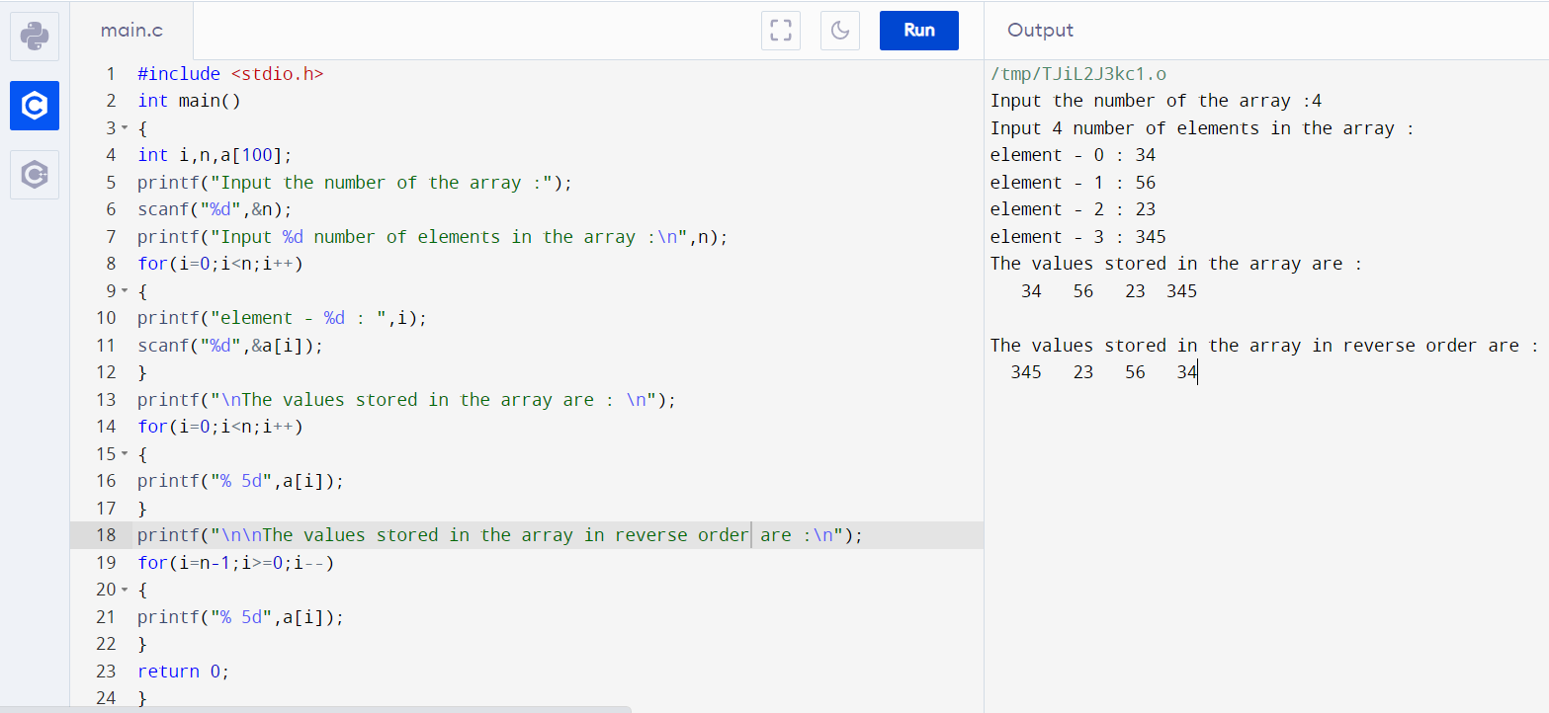

**Q2.** Find the sum of all elements of the array.

Ans – C Program & Output:

#include <stdio.h>

int main()

{

int a[1000],i,n,sum=0;

printf("Enter size of the array : ");

scanf("%d",&n);

printf("Enter elements in array : ");

for(i=0; i<n; i++)

{

scanf("%d",&a[i]);

}

for(i=0; i<n; i++)

{

sum+=a[i];

}

printf("sum of the array is : %d",sum);

return 0;

}

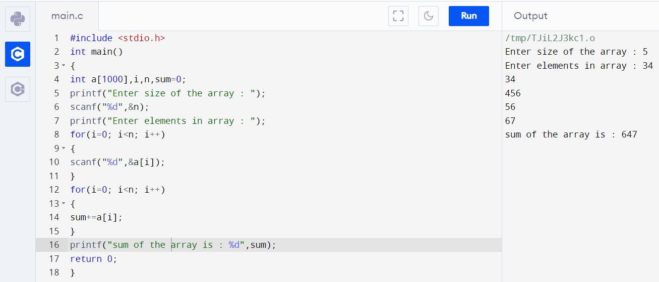

**Q3.** Copy the elements of one array into another array.

Ans – C Program & Output:

#include <stdio.h>

int main()

{

int arr1[100], arr2[100];

int i, n;

printf("Input the number of elements to be stored in the array :");

scanf("%d",&n);

printf("Input %d elements in the array :\n",n);

for(i=0;i<n;i++)

{

printf("element - %d : ",i);

scanf("%d",&arr1[i]);

}

for(i=0; i<n; i++)

{

arr2[i] = arr1[i];

}

printf("\nThe elements stored in the first array are :\n");

for(i=0; i<n; i++)

{

printf("% 5d", arr1[i]);

}

printf("\n\nThe elements copied into the second array are :\n");

for(i=0; i<n; i++)

{

printf("% 5d", arr2[i]);

}

return 0;

}

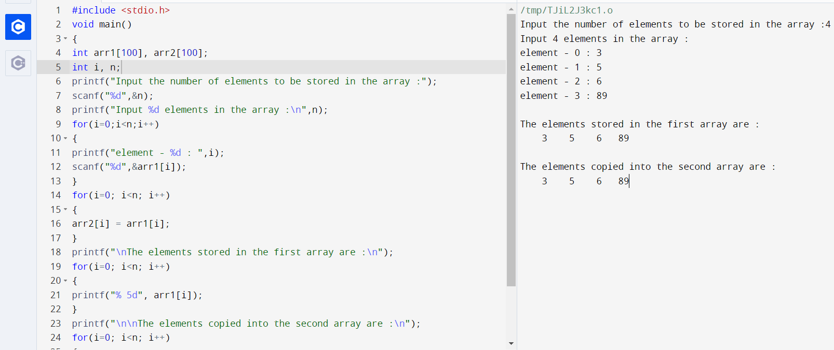

**Q4.** Count a total number of duplicate elements in an array.

Ans – C Program & Output:

#include <stdio.h>

int main()

{

int a[10000],b[10000],i,j,n,c=0 ;

printf("Enter size of the array : ");

scanf("%d", &n);

printf("Enter elements in array : ");

for(i=0; i<n; i++)

{

scanf("%d",&a[i]);

}

for(i=0; i<n; i++)

{

if(a[i]!=-1)

{

for(j=i+1; j<n; j++)

{

if(a[i]==a[j])

{

c++;

a[j]=-1;

}

}

}

}

printf("duplicate numbers in the array: %d",c);

return 0;

}

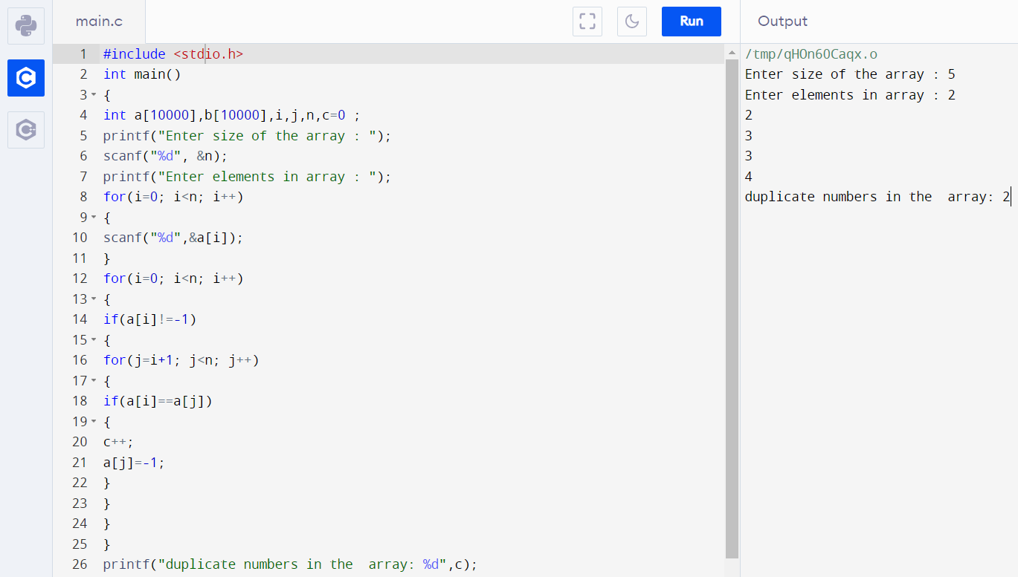

**Q5.** Find the maximum and minimum element in an array.

Ans – C Program & Output:

#include <stdio.h>

int main()

{

int arr1[100];

int i, mx, mn, n;

printf("Input the number of elements to be stored in the array :");

scanf("%d",&n);

printf("Input %d elements in the array :\n",n);

for(i=0;i<n;i++)

{

printf("element - %d : ",i);

scanf("%d",&arr1[i]);

}

mx = arr1[0];

mn = arr1[0];

for(i=1; i<n; i++)

{

if(arr1[i]>mx)

{

mx = arr1[i];

}

if(arr1[i]<mn)

{

mn = arr1[i];

}

}

printf("Maximum element is : %d\n", mx);

printf("Minimum element is : %d\n\n", mn);

return 0;

}

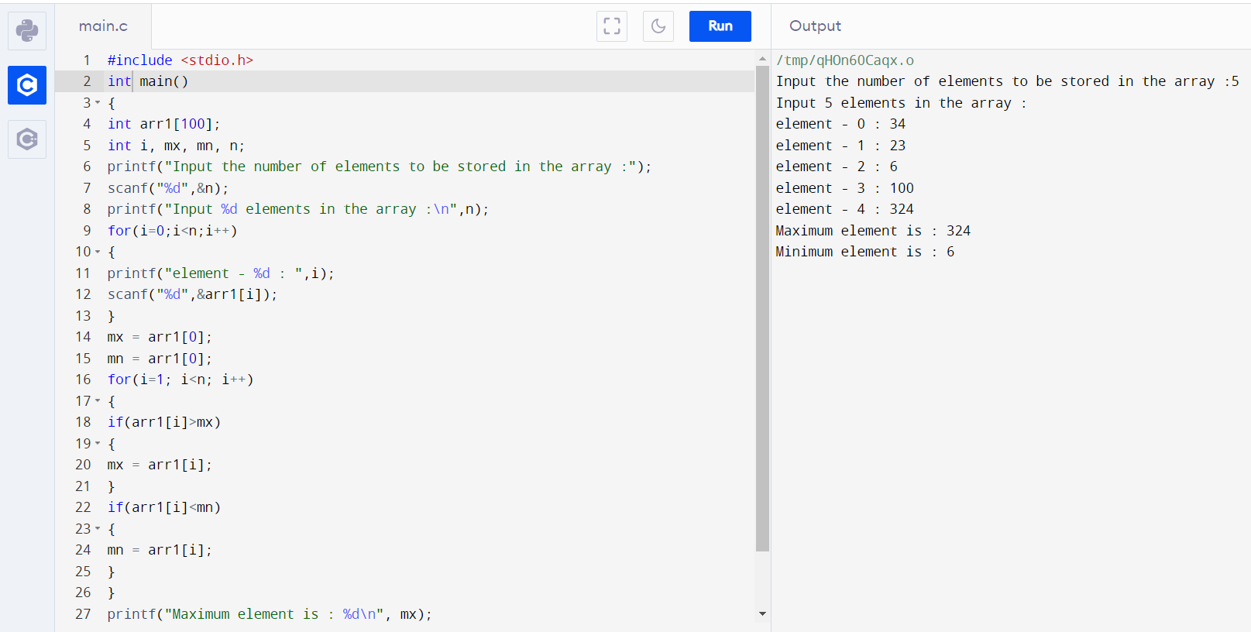

**Q6.** Separate odd and even integers in separate arrays.

Ans – C Program & Output:

#include <stdio.h>

int main()

{

int arr1[10], arr2[10], arr3[10];

int i,j=0,k=0,n;

printf("Input the number of elements to be stored in the array :");

scanf("%d",&n);

printf("Input %d elements in the array :\n",n);

for(i=0;i<n;i++)

{

printf("element - %d : ",i);

scanf("%d",&arr1[i]);

}

for(i=0;i<n;i++)

{

if (arr1[i]%2 == 0)

{

arr2[j] = arr1[i];

j++;

}

else

{

arr3[k] = arr1[i];

k++;

}

}

printf("\nThe Even elements are : \n");

for(i=0;i<j;i++)

{

printf("%d ",arr2[i]);

}

printf("\nThe Odd elements are :\n");

for(i=0;i<k;i++)

{

printf("%d ", arr3[i]);

}

return 0;

}

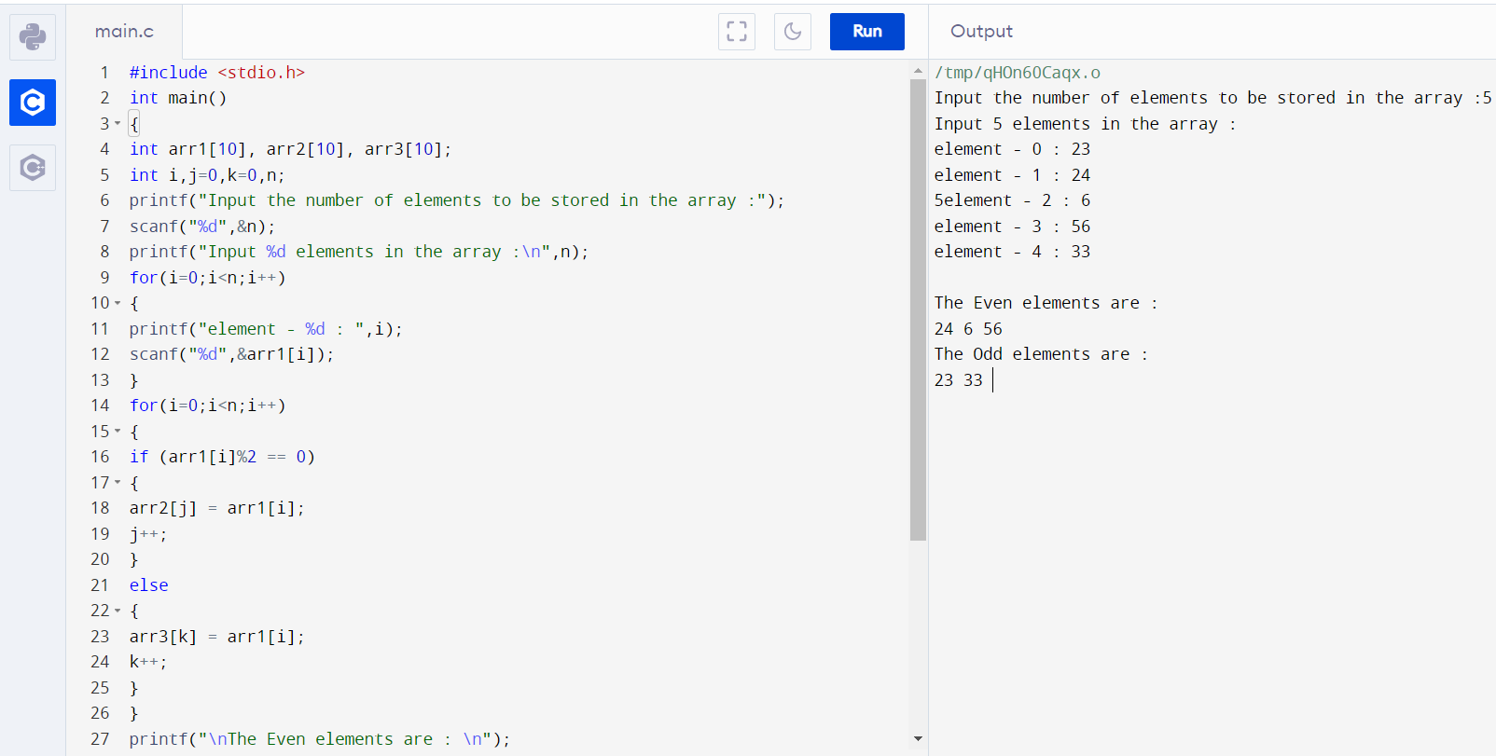

**Q7.** Insert New value in the array.

Ans – C Program & Output:

#include <stdio.h>

int main()

{

int arr1[100],i,n,p,inval;

printf("Input the size of array : ");

scanf("%d", &n);

printf("Input %d elements in the array:\n",n);

for(i=0;i<n;i++)

{

printf("element - %d : ",i);

scanf("%d",&arr1[i]);

}

printf("Input the value to be inserted : ");

scanf("%d",&inval);

printf("The exist array list is :\n ");

for(i=0;i<n;i++)

printf("% 5d",arr1[i]);

for(i=0;i<n;i++)

if(inval<arr1[i])

{

p = i;

break;

}

for(i=n;i>=p;i--)

arr1[i]= arr1[i-1];

arr1[p]=inval;

printf("\n\nAfter Insert the list is :\n ");

for(i=0;i<=n;i++)

printf("% 5d",arr1[i]);

return 0;

}

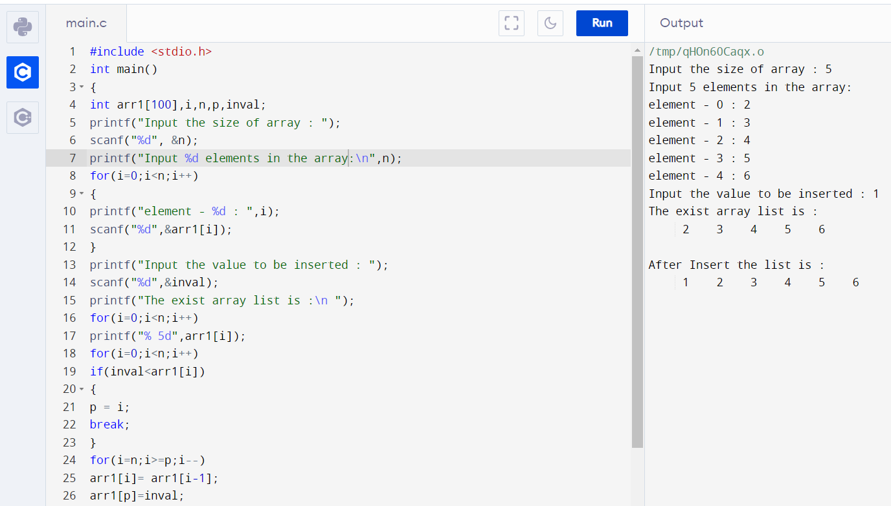

**Q8.** Delete an element at desired position from an array.

Ans – C Program & Output:

#include <stdio.h>

int main()

{

int arr1[50],i,pos,n;

printf("Input the size of array : ");

scanf("%d", &n);

printf("Input %d elements in the array :\n",n);

for(i=0;i<n;i++)

{

printf("element - %d : ",i);

scanf("%d",&arr1[i]);

}

printf("\nInput the position where to delete: ");

scanf("%d",&pos);

i=0;

while(i!=pos-1)

i++;

while(i<n)

{

arr1[i]=arr1[i+1];

i++;

}

n--;

printf("\nThe new list is : ");

for(i=0;i<n;i++)

{

printf(" %d",arr1[i]);

}

return 0;

}

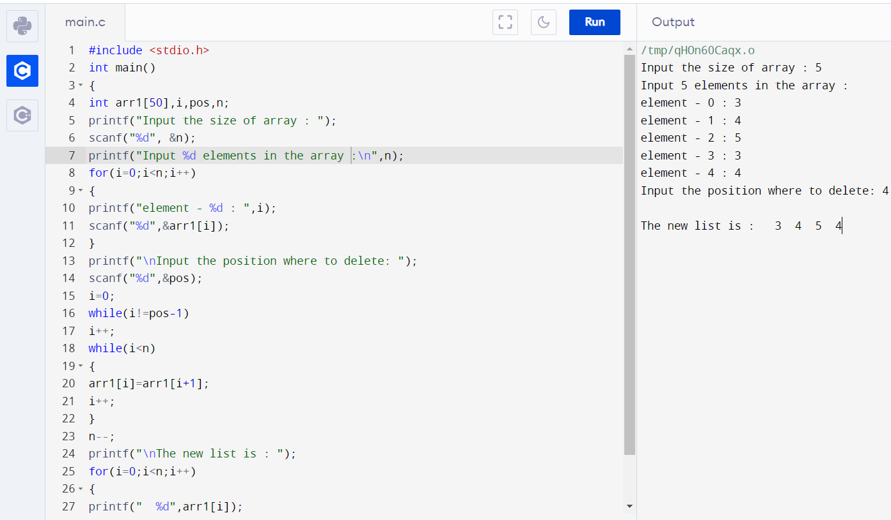

**Q9.** Find the second largest element in an array.

Ans – C Program & Output:

#include <stdio.h>

int main()

{

int arr1[50],n,i,j=0,lrg,lrg2nd;

printf("Input the size of array : ");

scanf("%d", &n);

printf("Input %d elements in the array :\n",n);

for(i=0;i<n;i++)

{

printf("element - %d : ",i);

scanf("%d",&arr1[i]);

}

lrg=0;

for(i=0;i<n;i++)

{

if(lrg<arr1[i])

{

lrg=arr1[i];

j = i;

}

}

lrg2nd=0;

for(i=0;i<n;i++)

{

if(i==j)

{

i++;

i--;

}

else

{

if(lrg2nd<arr1[i])

{

lrg2nd=arr1[i];

}

}

}

printf("The Second largest element in the array is : %d \n\n", lrg2nd);

return 0;

}

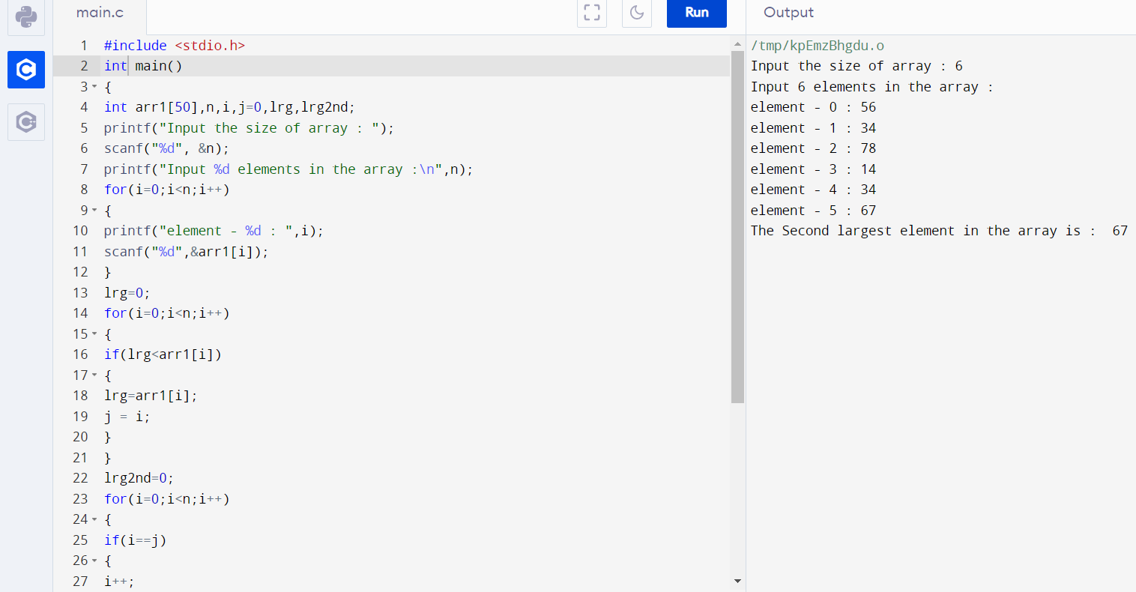

**Q11**. Multiplication of two square Matrices

Ans – C Program & Output:

#include<stdio.h>

#include<stdlib.h>

int main(){

int a[10][10],b[10][10],mul[10][10],r,c,i,j,k;

printf("enter the number of row=");

scanf("%d",&r);

printf("enter the number of column=");

scanf("%d",&c);

printf("enter the first matrix element=\n");

for(i=0;i<r;i++)

{

for(j=0;j<c;j++)

{

scanf("%d",&a[i][j]);

}

}

printf("enter the second matrix element=\n");

for(i=0;i<r;i++)

{

for(j=0;j<c;j++)

{

scanf("%d",&b[i][j]);

}

}

printf("multiply of the matrix=\n");

for(i=0;i<r;i++)

{

for(j=0;j<c;j++)

{

mul[i][j]=0;

for(k=0;k<c;k++)

{

mul[i][j]+=a[i][k]*b[k][j];

}

}

}

//for printing result

for(i=0;i<r;i++)

{

for(j=0;j<c;j++)

{

printf("%d\t",mul[i][j]);

}

printf("\n");

}

return 0;

}

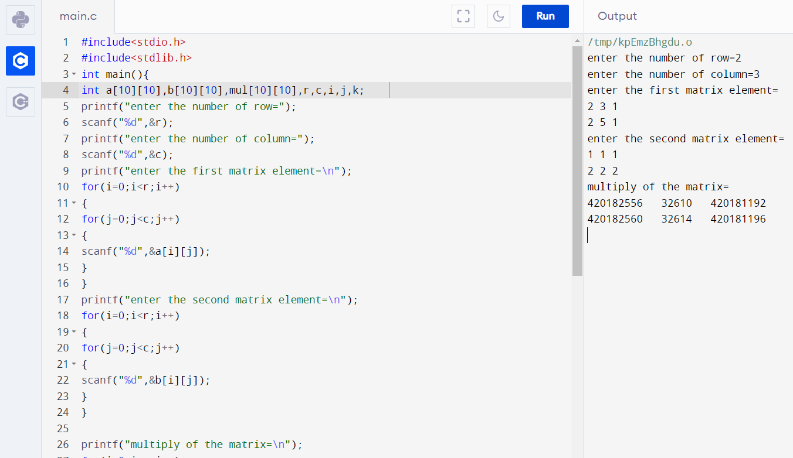

**Q12.**Find transpose of a given matrix.

Ans – C Program & Output:

#include <stdio.h>

int main()

{

int a[10][10], transpose[10][10], r, c, i, j;

printf("Enter rows and columns: ");

scanf("%d %d", &r, &c);

printf("\nEnter matrix elements:\n");

for (i = 0; i < r; ++i)

for (j = 0; j < c; ++j) {

printf("Enter element a%d%d: ", i + 1, j + 1);

scanf("%d", &a[i][j]);

}

printf("\nEntered matrix: \n");

for (i = 0; i < r; ++i)

for (j = 0; j < c; ++j)

{

printf("%d ", a[i][j]);

if (j == c - 1)

printf("\n");

}

for (i = 0; i < r; ++i)

for (j = 0; j < c; ++j) {

transpose[j][i] = a[i][j];

}

printf("\nTranspose of the matrix:\n");

for (i = 0; i < c; ++i)

for (j = 0; j < r; ++j) {

printf("%d ", transpose[i][j]);

if (j == r - 1)

printf("\n");

}

return 0;

}

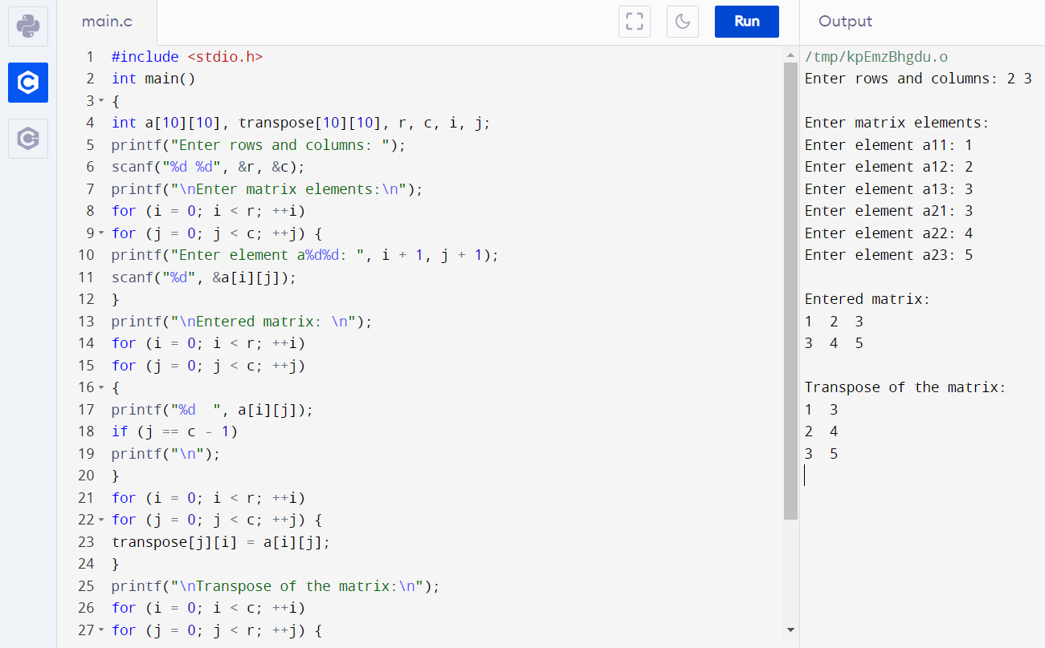

**Q13.** Find the sum of left diagonals of a matrix.

Ans – C Program & Output:

#include <stdio.h>

int main()

{

int i,j,arr1[50][50],sum=0,n,m=0;

printf("Input the size of the square matrix : ");

scanf("%d", &n);

m=n;

printf("Input elements in the first matrix :\n");

for(i=0;i<n;i++)

{

for(j=0;j<n;j++)

{

printf("element - [%d],[%d] : ",i,j);

scanf("%d",&arr1[i][j]);

}

}

printf("The matrix is :\n");

for(i=0;i<n;i++)

{

for(j=0;j<n ;j++)

printf("% 4d",arr1[i][j]);

printf("\n");

}

for(i=0;i<n;i++)

{

m=m-1;

for(j=0;j<n ;j++)

{

if (j==m)

{

sum= sum+arr1[i][j];

}

}

}

printf("Addition of the left Diagonal elements is :%d\n",sum);

return 0;

}

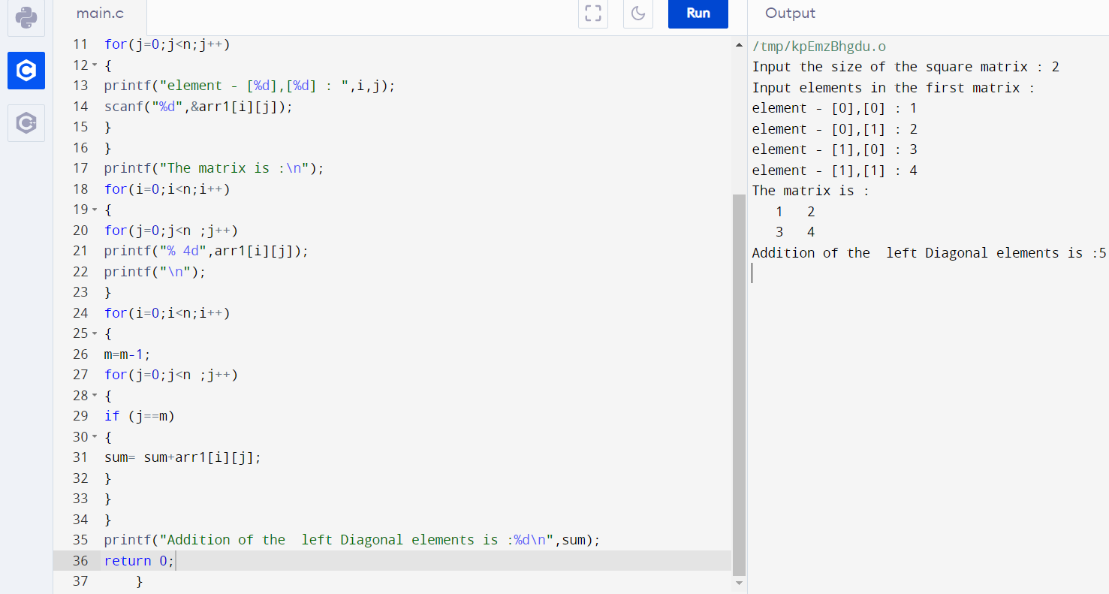

**Q14.** Check whether a given matrix is an identity matrix.

Ans – C Program & Output:

#include <stdio.h>

void main()

{

int arr1[10][10];

int r1,c1;

int i, j, yn =1;

printf("Input number of Rows for the matrix :");

scanf("%d", &r1);

printf("Input number of Columns for the matrix :");

scanf("%d",&c1);

printf("Input elements in the first matrix :\n");

for(i=0;i<r1;i++)

{

for(j=0;j<c1;j++)

{

printf("element - [%d],[%d] : ",i,j);

scanf("%d",&arr1[i][j]);

}

}

printf("The matrix is :\n");

for(i=0;i<r1;i++)

{

for(j=0;j<c1 ;j++)

printf("% 4d",arr1[i][j]);

printf("\n");

}

for(i=0; i<r1; i++)

{

for(j=0; j<c1; j++)

{

if(arr1[i][j] != 1 && arr1[j][i] !=0)

{

yn = 0;

break;

}

}

}

if(yn == 1 )

printf(" The matrix is an identity matrix.\n\n");

else

printf(" The matrix is not an identity matrix.\n\n");

}

